9.. Delete the row inserted in modification problem 3.

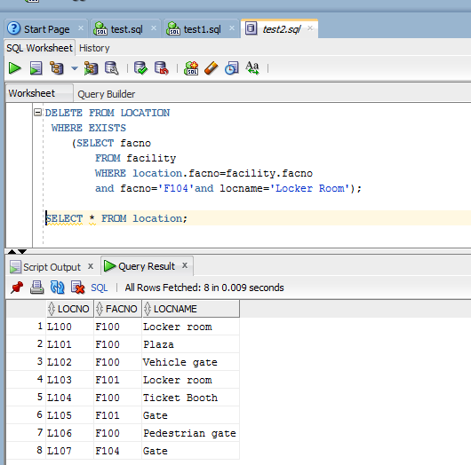

DELETE FROM LOCATION

WHERE EXISTS

(SELECT facno

FROM facility

WHERE location.facno=facility.facno

and facno='F104'and locname='Locker Room');